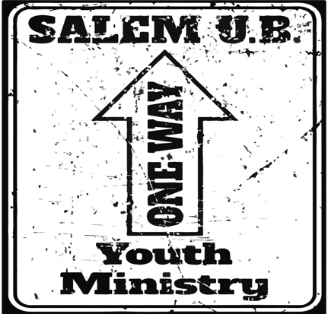
ONE WAY YOUTH MINISTRY
A Ministry of
Salem United Brethren Church
4349 LETTERKENNY ROAD
CHAMBERSBURG, PA 17201
Daryl “ Slugg” Kissinger (YOUTH PASTOR) 717-263-41
“COVID-19 Specific Permission Slip”
NAME OF ACTIVITY: _________________________________________
DATE OF ACTIVITY: _________________________________________
LOCATION OF ACTIVITY: _____________________________________
SPONSOR OF ACTIVITY: SALEM U.B. CHURCH YOUTH MINISTRY (1WYM)
DESCRIPTION OF ACTIVITY: ________________________for students (grades 6-12) and adult volunteers of 1WYM.
PARTICIPATION AGREEMENT: I acknowledge that participation in the activity described above involves risk to the participant (and to the participant’s parents or guardians, if the participant is a minor), and may result in various types of injury including, but not limited to, the following: sickness, exposure to infectious/communicable disease, bodily injury, death, emotional injury, personal injury, property damage, and financial damage.
I also recognize and acknowledge that COVID-19 is a viable health threat in our culture at this time and that my child will be interacting with other students and adults who are participating in this event.
In consideration for the opportunity to participate in the activity described above (the “name of activity”), the participant (or parent/guardian if the participant is a minor) acknowledges and accepts the risks of injury or sickness associated with participation in the activity. The participant (or parent/guardian) accepts personal financial responsibility for any injury or other loss sustained during the activity as well as for any medical treatment rendered to the participant that is authorized by the sponsor or its agents, employees, volunteers, or any other representatives (collectively referred to as the “activity sponsor”). Further, the participant (or parent/guardian) releases and promises to indemnify, defend, and hold harmless the activity sponsor for any injury or sickness arising directly or indirectly out of the described activity, whether such injury arises out of the negligence of the activity sponsor, the participant, or otherwise.
If a dispute over this agreement or any claim for damages arises, the participant (or parent/guardian) agrees to resolve the matter through a mutually acceptable alternative dispute resolution process. If the participant (or parent/guardian) and the activity sponsor cannot agree upon such a process, the dispute will be submitted to a three-member arbitration panel for resolution in accordance with the rules of the American Arbitration Association.
(Adapted for the Salem United Brethren Church from the “Activity Participation Agreement” established by Brotherhood Mutual Insurance Company 2020)

________________________________________ _____________________________________________
Signature of Parent/Guardian Date Signature of Participant Date
(if Participant is under 18 years of age)
_____________________________________________ _____________________________________________
Printed Name of Parent/Guardian Date Printed Name of Participant Date

